How to display Hindi alphabets on 16x2 LCD using 8051 microcontroller (AT89C51)
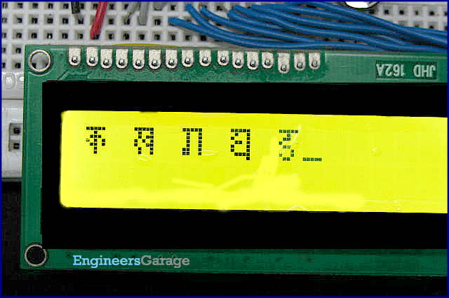
The conventional way of displaying a character or text on a 16x2 LCD uses English alphabets. But with the concept presented here, it is possible to display Hindi alphabets as well. The idea is to create custom characters on a 5x8 pixel matrix element corresponding to Hindi letters. These letters once created can be invoked and displayed as and when desired by interfacing LCD with AT89C51.
There are 8 symbol locations in LCD’s controller where a custom character can be stored. These locations can have a particular bitmap layout which would correspond to a custom made character. In this case these bitmap layouts are set according to Hindi alphabets. To display '' , the bitmap values are mapped to first base address location 64 (ASCII code 0).

This is achieved by first sending the address location (64) to LCD command register. Next, the bitmap values (31, 4, 14, 21, 13, 4, 4, 0) are sent to the LCD data register. Now the ‘’ alphabet gets stored at this address. Similarly other alphabets can also be stored at different (up to 8) addresses. Now whenever an alphabet is to be displayed, its location should be sent as a command instruction to LCD.

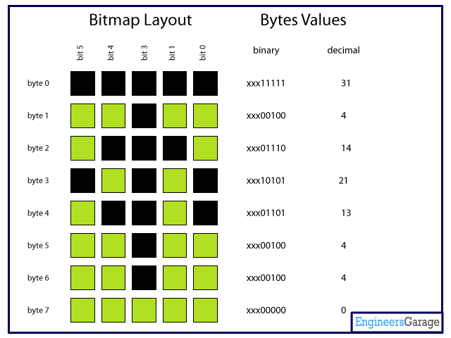

Here port P₂ is used to send the data byte to data pins of the LCD. The control pins (pin 4, 5 & 6) of LCD are connected to pins 0, 1 & 6, respectively, of port P₃. LCD’s pin 3 is connected to a preset of 10k to adjust the contrast on LCD screen.

Ckt Diagram
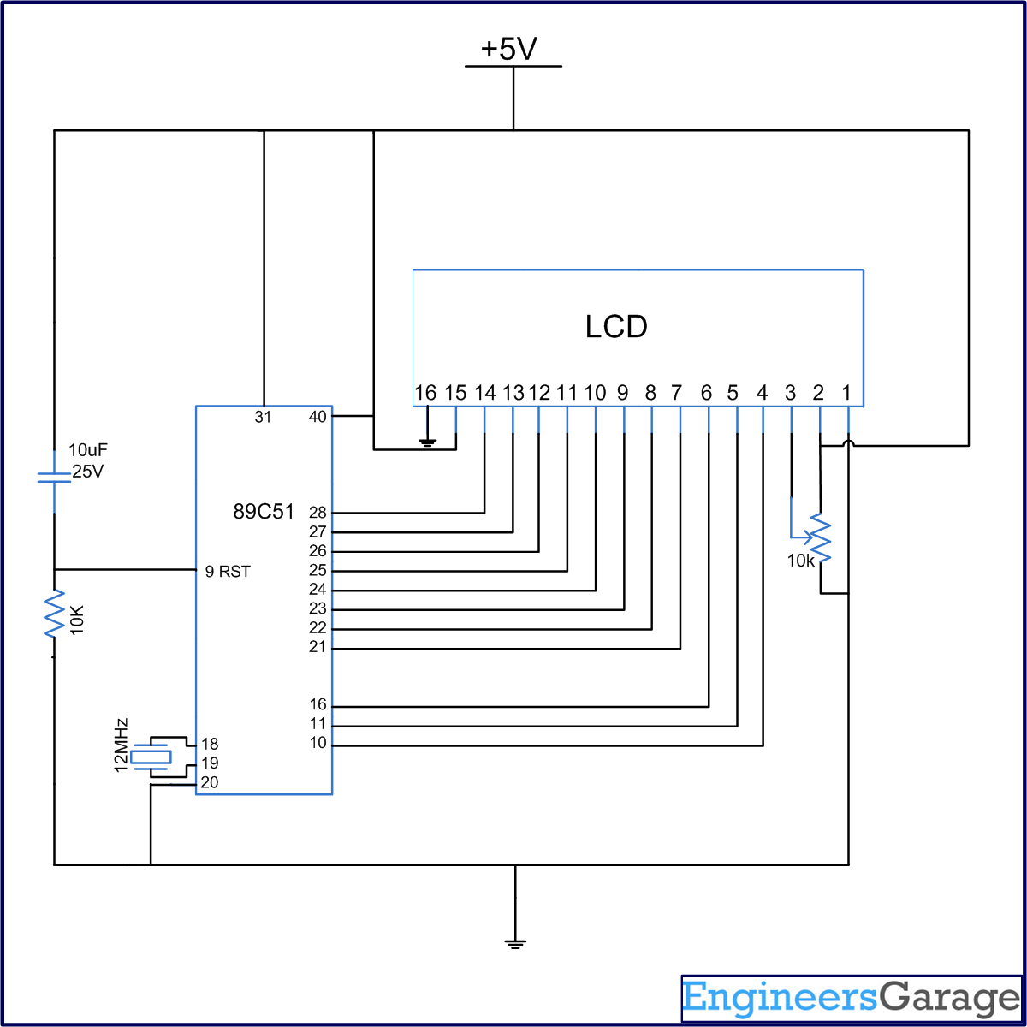

Program

/Program to display hindi alphabets. This program displays a set of five hindi characters at a time due to the size CG Ram.
// To display any other set of five characters use corresponding values from the array.

#include<reg51.h>
#define cmdport P3
#define dataport P2
sbit rs = cmdport^0; //Register select (RS) pin
sbit rw = cmdport^1; //Read write (RW) pin)
sbit en = cmdport^6; //Enable (EN) pin

void delay(unsigned int msec) //Time delay function
{
int i,j ;
for(i=0;i<msec;i++)
for(j=0;j<1275;j++);
}

void lcd_cmd(unsigned char item) //Function to send command to LCD
{
dataport = item;
rs= 0;
rw=0;
en=1;
delay(1);
en=0;
}

void lcd_data(unsigned char item) // Function to send data to LCD
{
dataport = item;
rs= 1;
rw=0;
en=1;
delay(1);
en=0;
}

lcd_shape(unsigned char *letter,int j) // Function to create custom shapes
{
int i;
lcd_cmd(j);
for(i=0;i<8;i++)
{
lcd_data(*letter);
letter++;
}
}

void main()
{
unsigned char letter[][8]= {31,4,14,21,13,4,4,0,31,9,11,21,19,9,9,0,31,9,9,9,9,25,25,0,31,9,17,13,17,17,15,1,31,4,12,16,12,2,18,12};
/*{0,31,2,26,10,6,2,0,
31,12,16,12,16,22,15,1,31,1,7,21,21,13,0,0,5,29,17,31,5,29,25,9,1,1,29,7,5,29,1,0};*//*{31,4,4,24,16,17,14,0,31,4,4,14,17,17,14,0,
31,4,12,16,12,2,18,12,31,4,12,16,22,14,0,0,31,21,21,21,21,9,0,0};*//*{31,1,15,9,9,1,0,0,15,13,5,9,15,1,0,0,31,2,14,16,19,14,2,0,3,25,17,12,17,17,15,1,
31,1,1,31,9,1,1,0,31,9,9,9,15,1,1,1};*//*{31,9,9,9,7,1,1,1,31,20,20,31,5,5,5,0,31,2,30,26,22,30,2,2,0,26,26,10,30,26,2,2,31,10,10,10,30,26,2,2,};*/
/*{31,29,5,5,9,31,1,1,31,12,2,2,28,8,4,3,31,1,1,27,21,21,17,9,31,2,30,18,18,30,2,2,29,21,29,5,25,25,9,5};{17,25,21,19,31,1,1,1,31,25,
5,5,5,15,17,9,31,4,28,16,28,16,16,30,9,21,13,23,17,21,13,5,2,18,10,6,6,10,18,2};*///assigning values of alphabets to an array

unsigned char i=0;
char a = 0x80; // Set cursor to first position of first line
int z;
lcd_cmd(0x38);
lcd_cmd(0x0e);
delay(50);
lcd_cmd(0x01); //Clear LCD screen
delay(50);
while(1)
{
z=64;
a=0x80;
for(i=0;i<5;i++)
{
lcd_shape(&letter[i][0],z); //Send different alphabet values to shape func to custom different alphabets
delay(50);
lcd_cmd(a); //Move cusrsor to ath position
lcd_data(i); //Display the alphabet on LCD
delay(50);
a=a+2;
z=z+8; // Change the address register where values are to be stored(e.g. 64,72,80.......)
}
lcd_cmd(0x01); //Clear LCD screen
}
}

